Forms

Knowledge Check|
- Understand the importance of validating HTML forms before submitting them to a server.
- Describe the two types of client-side form validation, built-in form validation and validation using JavaScript.
- Write validation checks for HTML forms by using validation attributes.
- Understand JavaScript Constraint Validation API provides more control and customization of form validation.
- Use JavaScript to write custom error messages and add custom styling to the errors.
- Understand forms can also be validated without using Constraint Validation API, which is useful in certain cases.

Answers
Q1:
The reason it is important to submit forms that have been validated is that this step prevents security breaches and optimizes the data collection procedure. By allowing the user to dynamically correct the information they are imputing using the developers’ guidelines a lot of time is saved.
This is not an excuse to not double check the information when it eventually reaches the server but it should already have been curated, at least superficially.
There’s no reason to not validate forms with all the accommodations and shortcuts provided to programmers, as a simple HTML5 validation can do a lot while requiring no JavaScript expertise.
Q2-5:
Built-in form validation – done by using the HTML5 properties and attributes that exist for every form, input element and the submit button. It allows to check for patterns, length, type of information, no empty fields and a couple more requirements. It is simple and easy to implement, but there’s quite a bit of limitation for this very reason. Also, legacy browsers do not have these tools.
JavaScript Validation – done by using the special properties of the HTML Form elements available to the DOM as part of the Constraint Validation API.
It is available for: button, fieldset, input, output, select, textarea.

And makes these properties usable: validationMessage, validity, willValidate.
Validity is an object that has access to the properties: patternMismatch, tooLong, tooShort, rangeOverflow, rangeUnderflow, typeMismatch, valid, valueMissing.
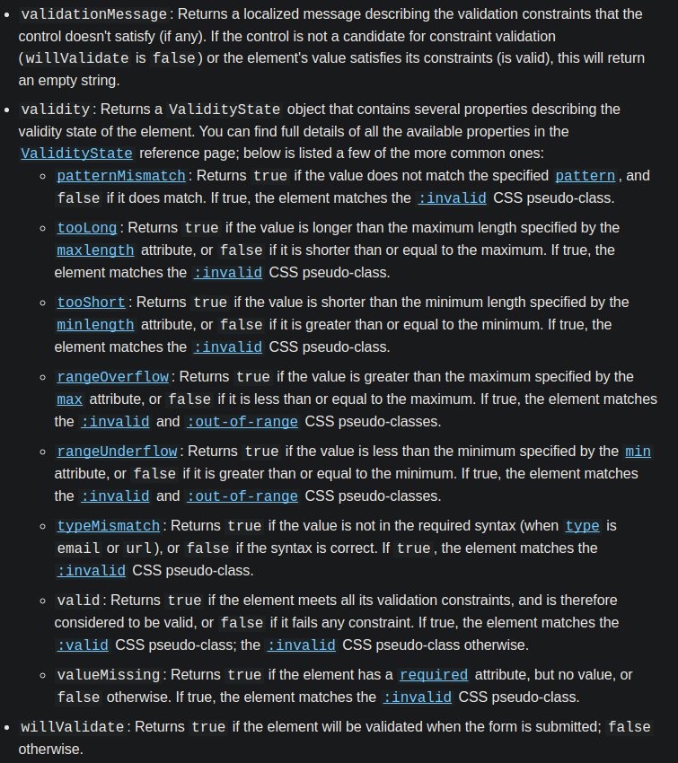

It makes some methods available too for the previous DOM elements and the form element.
Methods: checkValidity(), reportValidity(), setCustomValidity(message).
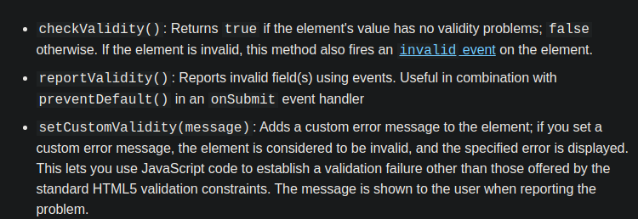
Simply put, validating by using JavaScript is far more powerful and flexible than HTML5, but also more difficult and thorough.
Q6:
Form validation without the use of the Constraint Validation API is possible (and necessary) when dealing with legacy browsers. This is done by implementing from scratch the scripts necessary to generate, catch and answer to the events happening in the HTML.
Note: I found this quite dull and unlikely to happen to me anytime soon. I think these particular guidelines and implementations for legacy browser are something for the professional and not of much importance for the apprentice, beyond knowing that it exists.

Extra

aria-live
Accessible Rich Internet Applications (ARIA) is an attribute used within many HTML elements so their information is passed to assistive technologies, such as screen readers. Their focus is providing user with disabilities a better browsing experience.
As an attribute “aria-live” has the settings:
“off” – the default.
“polite” – will announce changes whenever the reader is idle. Use this most of the time.
“assertive” – will announce changes right away, interrupting current read. It is quite disruptive and should be used sparingly.

Listening for events on HTML form elements
Event type ‘submit’ occurs when a form’s submit button is pressed. This can be disabled by capturing the event in any way and using
event.preventDefault()
Event type ‘input’ occurs whenever the information inside an input element is modified, for example, an email input each time the user completes a keyup and a character is written.
